**Monitor Unencrypted S3 Buckets Using AWS Lambda and Boto3**

**Objective:**To enhance your AWS security posture by setting up a Lambda function that detects any S3 bucket without server-side encryption.

Task: Automate the detection of S3 buckets that don't have server-side encryption enabled.

**Task:**Automate the detection of S3 buckets that don't have server-side encryption enabled.

**Instructions:**

**1. S3 Setup:**

- Navigate to the S3 dashboard and create a few buckets. Ensure that a couple of them don't have server-side encryption enabled**.**

Unable to create any bucket without SSE as AWS has defaulted encryption.

Tried with API option as well to create but didn’t worked.

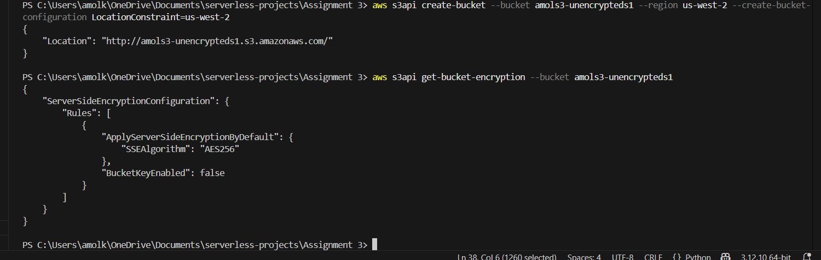

**2. Lambda IAM Role:**

 - In the IAM dashboard, create a new role for Lambda.

   - Attach the `AmazonS3ReadOnlyAccess` policy to this role.

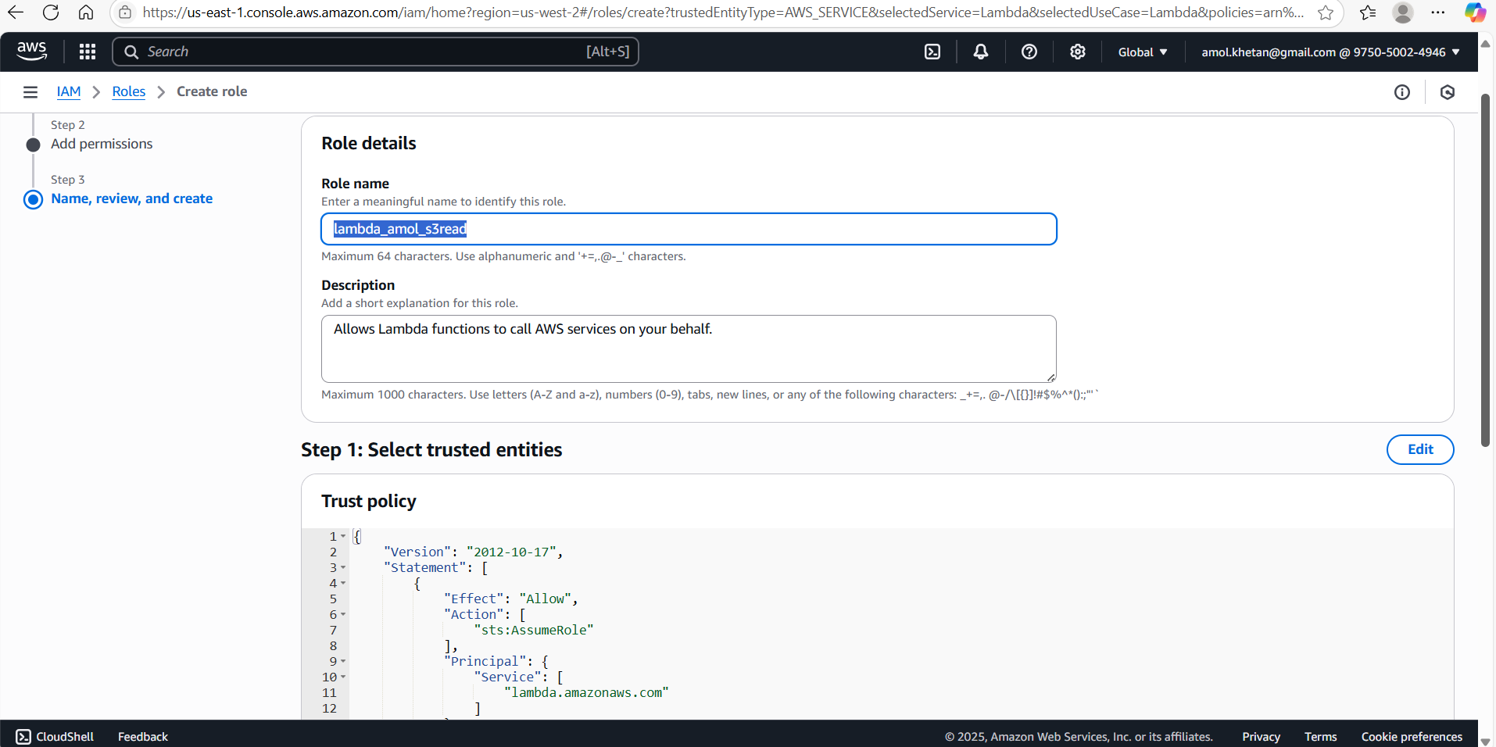

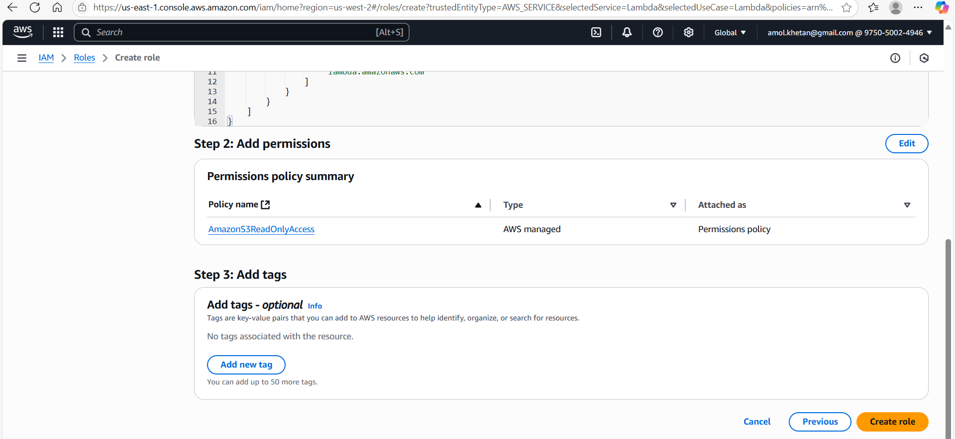

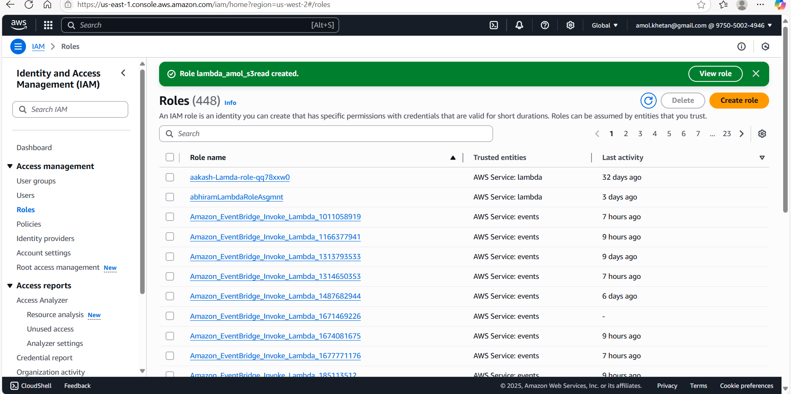

**3. Lambda Function:**

 - Navigate to the Lambda dashboard and create a new function.

   - Choose Python 3.x as the runtime.

   - Assign the IAM role created in the previous step.

   - Write the Boto3 Python script to:

     1. Initialize a boto3 S3 client.

     2. List all S3 buckets.

     3. Detect buckets without server-side encryption.

     4. Print the names of unencrypted buckets for logging purposes.

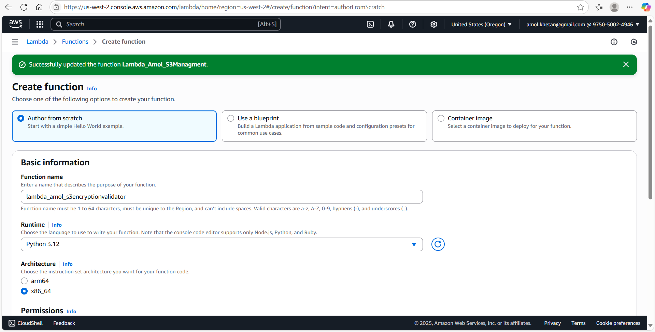

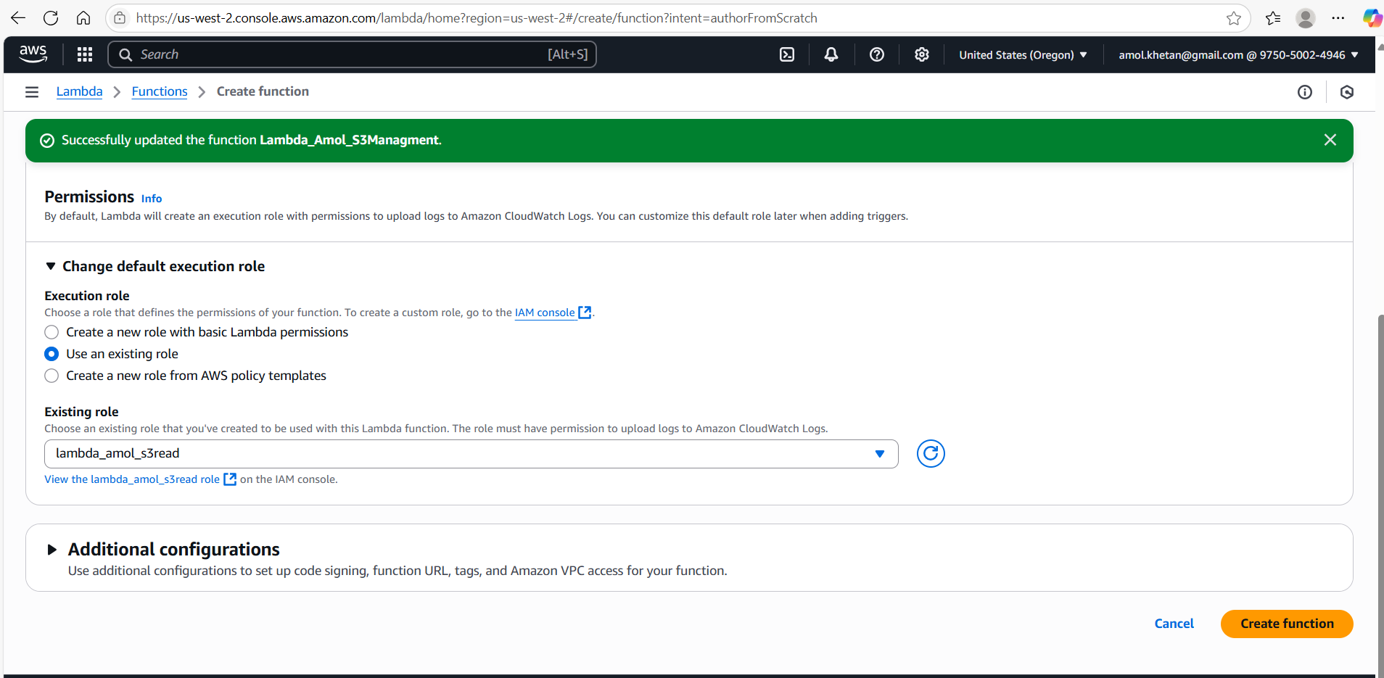

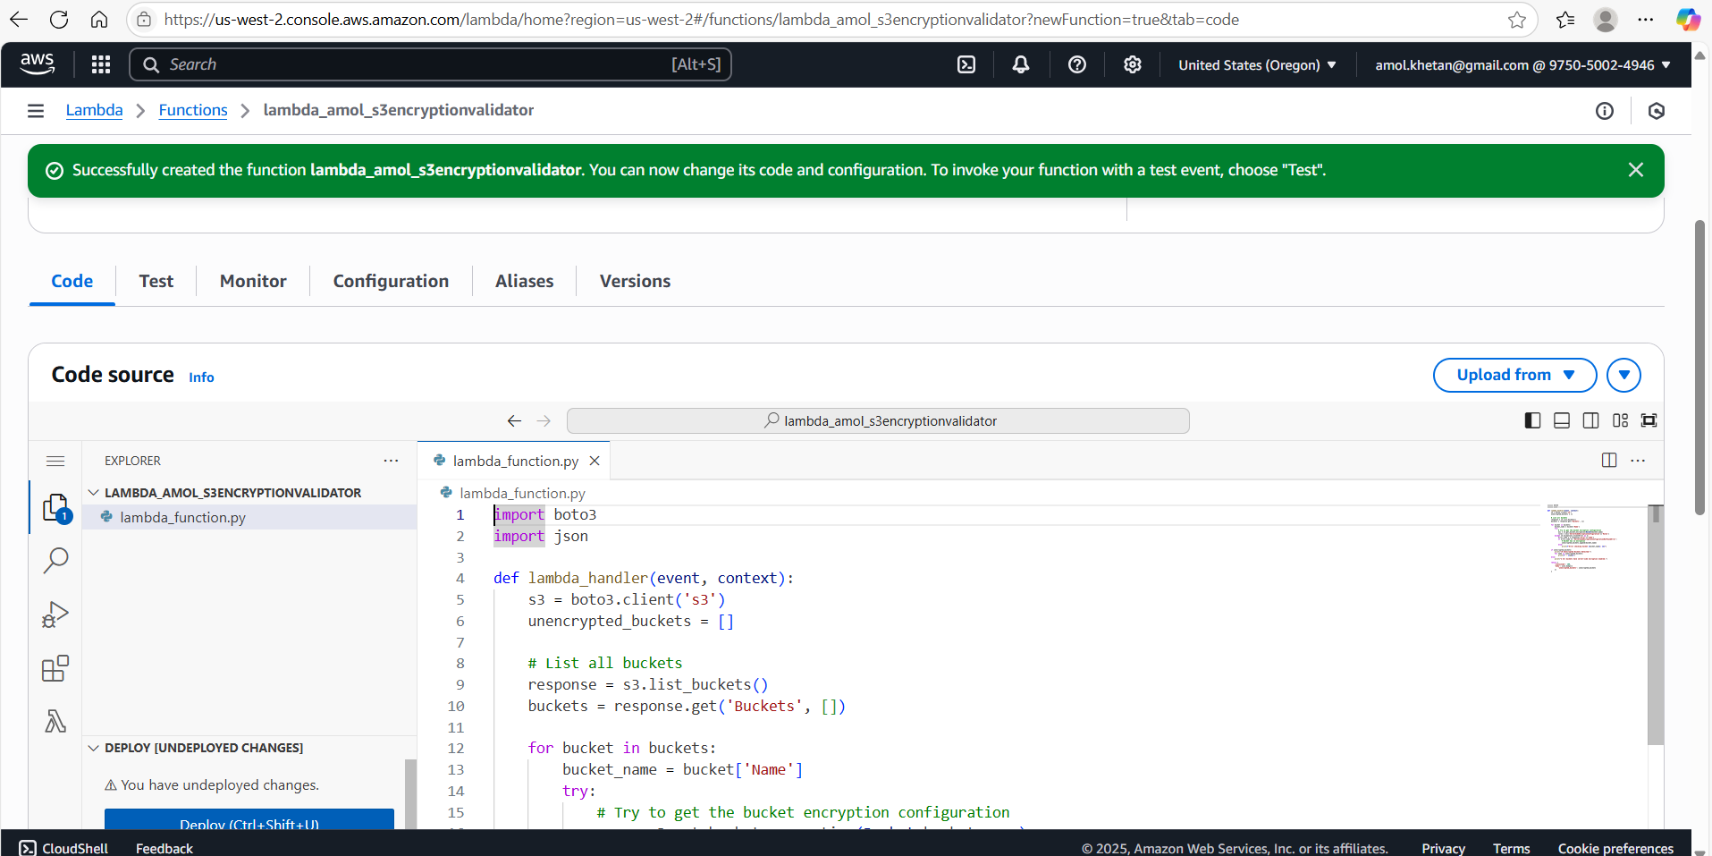

**4. Manual Invocation:**

   - After saving your function, manually trigger it.

   - Review the Lambda logs to identify the buckets without server-side encryption.

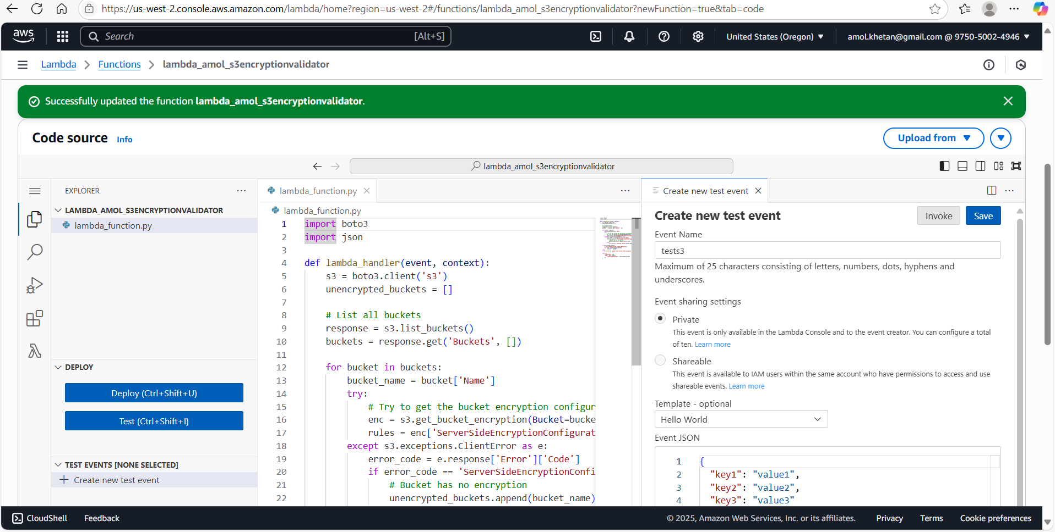

**Created Test event and invoked. It was getting timeout.**

**Increased Timeout from Configuration section of Lambda function and restricted region to us-west-2.**

**Lambda Output is below (No Unencrypted buckets found as SSE is default feature of Aws)**

**Status: Succeeded**

**Test Event Name: tests3**

Response:

{

  "statusCode": 200,

  "body": "{\"unencrypted_buckets\": []}"

}

Function Logs:

START RequestId: 2518d4c9-5308-441c-925f-1e55bc4486b4 Version: $LATEST

✅ All buckets in us-west-2 have server-side encryption enabled.

END RequestId: 2518d4c9-5308-441c-925f-1e55bc4486b4

REPORT RequestId: 2518d4c9-5308-441c-925f-1e55bc4486b4  Duration: 19417.94 ms   Billed Duration: 19418 ms   Memory Size: 128 MB Max Memory Used: 89 MB  Init Duration: 268.73 ms

Request ID: 2518d4c9-5308-441c-925f-1e55bc4486b